Introduction to Worker Health and Safety
for English Speakers of Other Language Classes
Instructor guide
Workshop purpose: To provide individuals with limited English proficiency basic information about workplace dangers and rights under OSHA, with a focus on chemical exposure - while providing them with an opportunity to learn vocabulary and develop their English competency.

Basic agenda:
9:10 Introductory questions
9:20 Pre Assessment
9:30 Skit part 1: Safety and health problems at work
10:00 Hazard mapping activity; 10:30 report back
10:50 break
11:00 Skit part 2: Worker health and safety rights, taking action
11:15 small group
11:35 Final questions
11:50 Post Assessment
Introductions (10 minutes)
Questions for the class:
Stand up if you work right now. (Stay standing)
Stand up if you worked in the last three years. (Sit down)
Stand up if there is something you like about your work (I will call on a couple: Where did they work; what did they like)
Stand up if you or someone you know has been hurt at work (call on a couple of people, what was the work? How did they get hurt)
Pre–assessment (10 min)
Instructor explains that the assessment is to help him/her make sure the workshop is helpful and not to judge the students. The instructor reads the five questions (see Materials Appendix). Students will circle True or False.

Safety and health problems at work – Skit part 1 (20 min)
Three students volunteer – two will read (Patty and Erica), and one will ask the class the questions.
Student asks the class these questions:
What is [Organization presenting workshop]?
Why did Patty go to [Organization presenting workshop]?
What are the problems at Patty’s job?
What is a safety hazard? What safety hazards did Patty have at work?
What is a health hazard? What health hazards did Patty have at work?
This material was produced under grant number SH-31173-SH7, from the Occupational Safety and Health Administration, U.S. Department of Labor. It does not necessarily reflect the views or policies of the U.S. Department of Labor, nor does the mention of trade names, commercial products, or organizations imply endorsement by the U.S. Government.
Hazard Mapping (45 min)
Instructor will ask them to give examples of safety hazards and then of health hazards, referencing the jobs identified in the opening “stand up” activity.
Present a drawing of a workplace – and ask students to identify examples of safety and health dangers.
Students break into groups to draw a workplace where one of the students worker and mark the safety dangers in red and health dangers in blue. (25 minutes)
Students then present the workplace and the dangers to the rest of the group. Other students will be able to add additional dangers. (20 min)
Worker rights / taking action – Skit part 2 (45 min).
Instructor tells the class that we are going to discuss what Patty can do about her problems at the cleaning company. After we learn what Patty can do, the class will think of a problem they or someone else had and discuss what they would do.
Two students volunteer to read the script (Skit Part 2)
Instructor reviews with the class:
What rights do workers have?
Students are invited to pick up a sign that has a specific right and read it out loud. The sign is posted in front of the room.
The instructor asks groups to discuss and be prepared to report back what they learned.
What steps can they take?
What questions do you have?
Teams report back on what they learned and what questions they have.
Marcy or others can answer the questions.
Questions in small group:
Have you or someone you know had a safety or health hazard at work?
What did you or they do?
What steps would you take if you had a safety or health hazard:
- Talk to coworkers?
- Talk to the boss?
- Call OSHA yourself?
- Ask [Organization presenting this workshop] to help you call OSHA?
- Is there something else you would do?

Post assessment:
Instructor reads the questions and students circle True or False on the form.
Closing activity
Students are invited to ask questions, and encouraged to contact the organization leading the presentation. Contact information is shared with students.
A. What do I know (before the workshop)

- OSHA is a government agency that helps ensure that workers are safe and healthy.
TRUE FALSE DON’T KNOW

- A hazard on the job is something that can injure you or make you sick.
TRUE FALSE DON’T KNOW

- Only workers who work in this country legally (workers who are “documented’)
are protected under health and safety laws.
TRUE FALSE DON’T KNOW

- It is legal for your employer to fire you if you complain about a health and safety problem.
TRUE FALSE DON’T KNOW

- MassCOSH is an organization that can help you learn about your rights at work
TRUE FALSE DON’T KNOW

B. What do I know (after the workshop)

- OSHA is a government agency that helps ensure that workers are safe and healthy.
TRUE FALSE DON’T KNOW

- A hazard on the job is something that can injure you or make you sick.
TRUE FALSE DON’T KNOW

- Only workers who work in this country legally (workers who are “documented’)
are protected under health and safety laws.
TRUE FALSE DON’T KNOW

- It is legal for your employer to fire you if you complain about a health and safety problem.
TRUE FALSE DON’T KNOW

- MassCOSH is an organization that can help you learn about your rights at work
TRUE FALSE DON’T KNOW
B. SKIT PART 1:
Safety and health problems at work
Erica:
“Hello, Patty. My name is Erica. Welcome to [Organization presenting workshop]. We help people who have problems at work. Workers come to us if they are hurt or if they did not get paid. Do you have problems at your work?”
Patty:
“Yes, Erica. I work at Tough Cleaners. I clean office buildings. Every day, I must clean the recycling bins. Last week, I cut my hand on broken glass in the bin. I put on a bandage. When I went home, the bandage was full of blood. I am afraid to put my hands in the bin again.”
Erica:
“Patty, that sounds very painful. Do you have other safety hazards, things that can hurt you?”
Patty:
“Yes, the floors are slippery. I sometimes fall on the floor.”
Erica:
“Do you have any health hazards, things that can make you sick?”
Patty:
“I use strong cleaning chemicals to clean the bathroom. I feel dizzy and I cannot breathe. My coworker Marcia has a rash from the chemicals.”
What is XCOSH?
Why did Patty go to XCOSH?
What are the problems at Patty’s job?
What is a safety hazard? What safety hazards did Patty have at work?
What is a health hazard? What health hazards did Patty have at work?

C. Skit Part 2:
Worker Rights and Taking Action
Erica: “Patty, let tell you about some of your rights.
If you are hurt at work, you have a right to workers compensation. Workers compensation is an insurance paid for by your employer. Workers compensation pays medical bills for a work injury. If you can not go to work for five or more days, it pays part of your salary, 60 percent.
You have a right to a safe workplace. You also have a right to a healthy workplace.
You have a right to know if the chemicals you use are dangerous.
Your employer must provide training in how to work with chemicals safely.
If the chemicals can harm you, your employer may need to provide gloves or eye protection.
The national agency that protects your rights is called OSHA: Occupational Safety and Health Administration. You have the right to call OSHA if you are not safe.
OSHA will not show your name to the boss.
All workers can call – even immigrants who do not have documents. It is against the law for an employer to punish you for asking for a safe workplace or for calling OSHA.

Students are asked to bring up signs that match the rights:
Small group questions:

Have you or someone you know had a safety or health hazard at work?
What did you or they do?
What steps would you take if you had a safety or health hazard:
- Talk to coworkers?
- Talk to the boss?
- Call OSHA yourself?
- Ask [Organization presenting workshop] to help you call OSHA?
- Is there something else you would do?

D. Signs to post after students define safety and health hazards.
A safety hazard is a danger that can cause an injury. It can hurt or kill you.

A health hazard is a danger that can make you sick or harm your body.

E. Sample workplace hazard map
Instructors can draw their own sample workplace on flip chart paper. The sample hazard map drawing below was taken from
Youth @ Work, Talking Safety (Center for Disease Control, National Institute for Occupational Safety and UC Berkeley LOHP) .

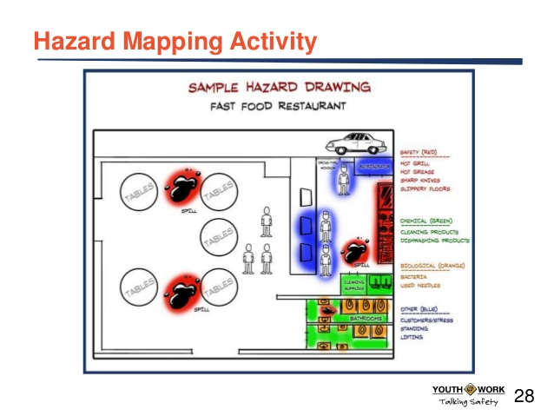

F. Signs with Rights

You have a right to Workers Compensation if you are injured at work
You have a right to a safe and healthy workplace

You have a right to training in how to use chemicals safely

You have a right to call OSHA (Occupational Safety and Health Agency) if you feel unsafe at work

